Patrik Martic 9c 03/16/2022

**Add fffmpeg to** [**https://repl.it/**](https://repl.it/)

1. open shell and type in: npm install ffmpeg-static

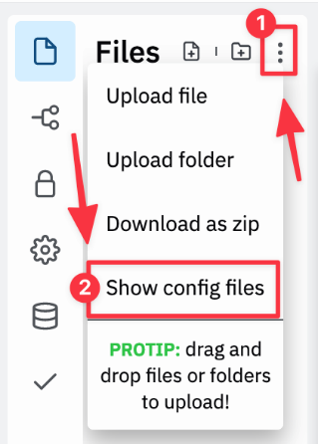

1. show config files 2.)
2. open “replit.nix” file
3. add pkgs.ffmpeg to deps = [];

e.g. deps = [ pkgs.ffmpeg ];

1. add pkgs.ffmpeg.bin to env in

PYTHON_LD_LIBRARY_PATH = pkgs.lib.makeLibraryPath [];

e.g. PYTHON_LD_LIBRARY_PATH = pkgs.lib.makeLibraryPath [pkgs.ffmpeg.bin];

1. your “replit.nix” should now look something like this:

finished “replit.nix” file:

{ pkgs }: {

deps = [

pkgs.python38Full

**# ffmpeg – STEP 4 IN INSTRUCTION**

pkgs.ffmpeg

];

env = {

PYTHON_LD_LIBRARY_PATH = pkgs.lib.makeLibraryPath [

# Neded for pandas / numpy

pkgs.stdenv.cc.cc.lib

pkgs.zlib

# Needed for pygame

pkgs.glib

# Needed for matplotlib

pkgs.xorg.libX11

**# ffmpeg – STEP 5 IN INSTRUCTION**

pkgs.ffmpeg.bin

];

PYTHONBIN = "${pkgs.python38Full}/bin/python3.8";

LANG = "en_US.UTF-8";

};

}